**Task 3**

1. Create a Issue in your github repository.
2. Raise a pull request.
3. Merge A pull request.
4. Reject a pull request with proper comments.
5. Add a Dependabot alerts in your github.(for above cases)
6. Stash changes
7. Create a release your package
8. Setup a Projects Board for your project.
9. The host repository is like below:

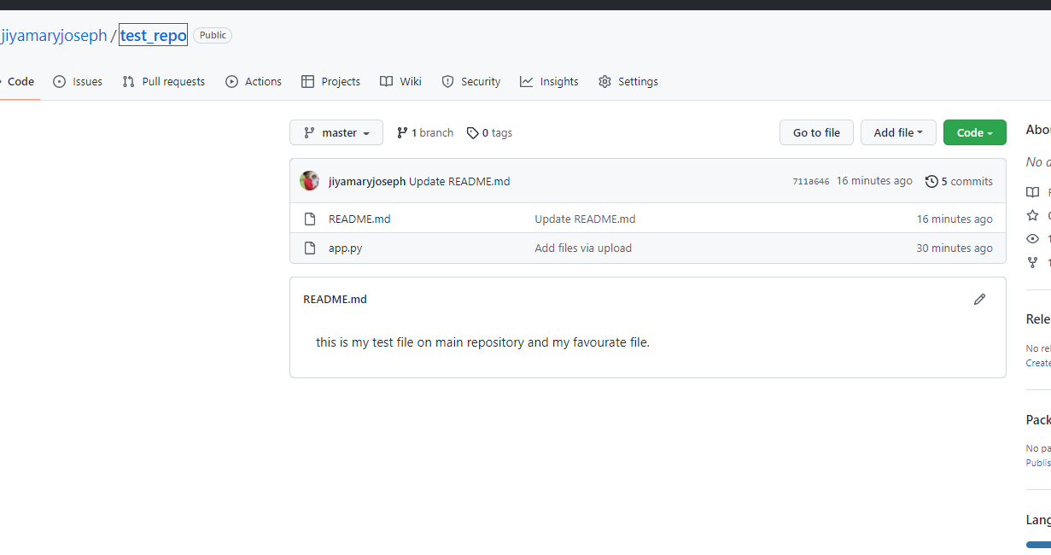

1. Here I have detected some errors and and uploaded important datas in my repository as shown below.

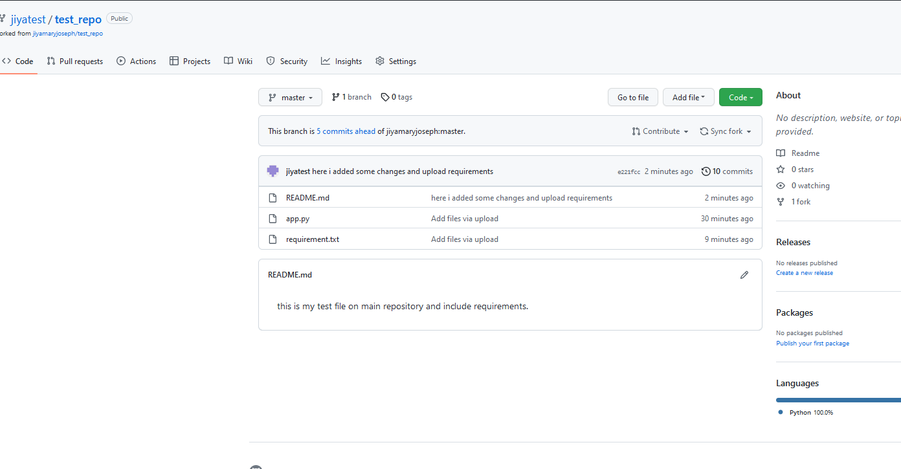

1. And make some pull request:

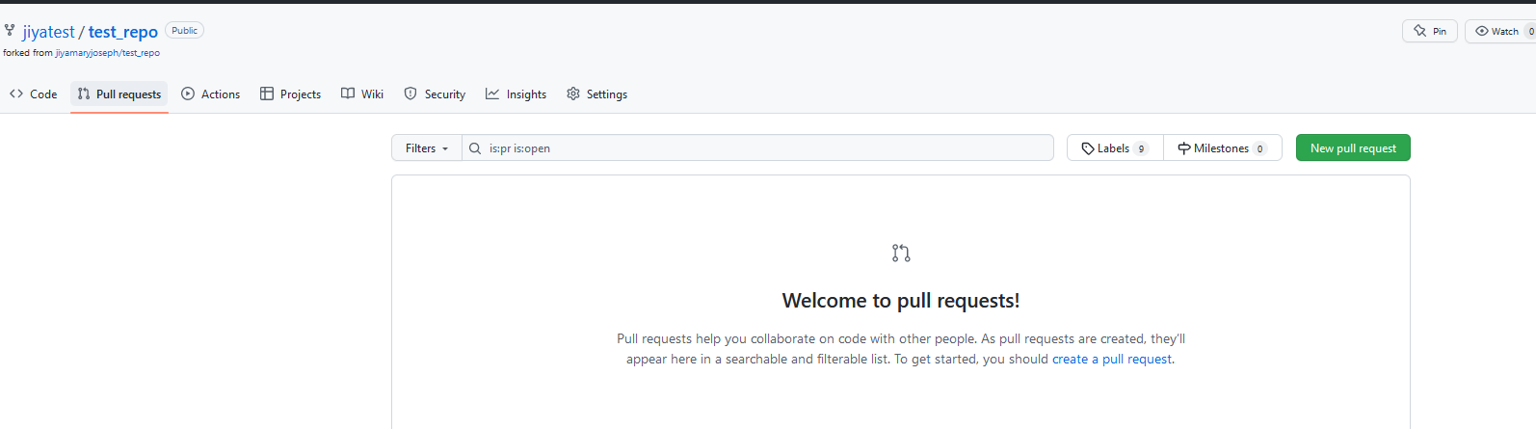

1. Merge the pull request

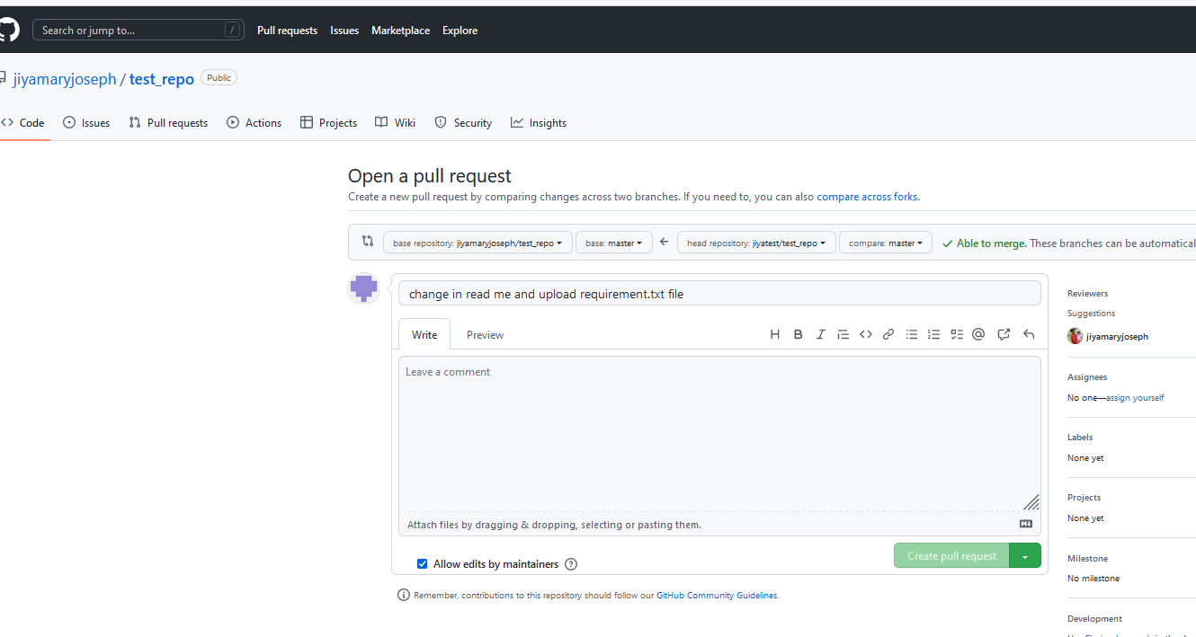

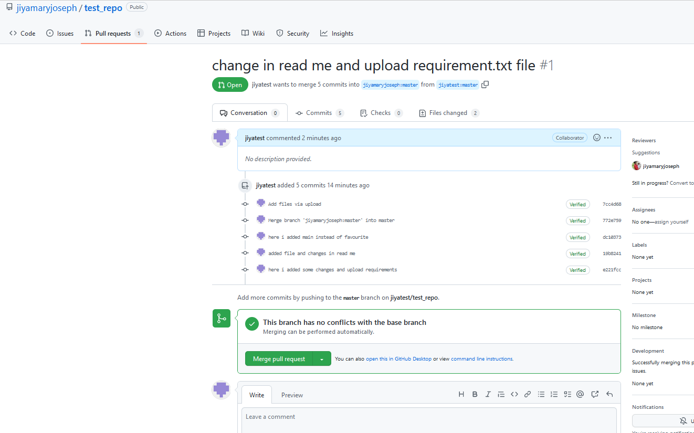

1. Reject a pull request with proper comments.

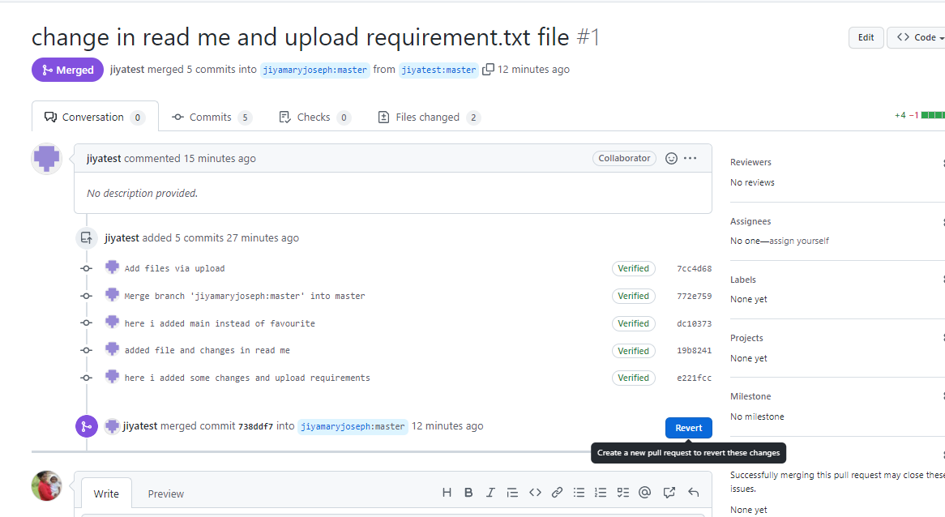

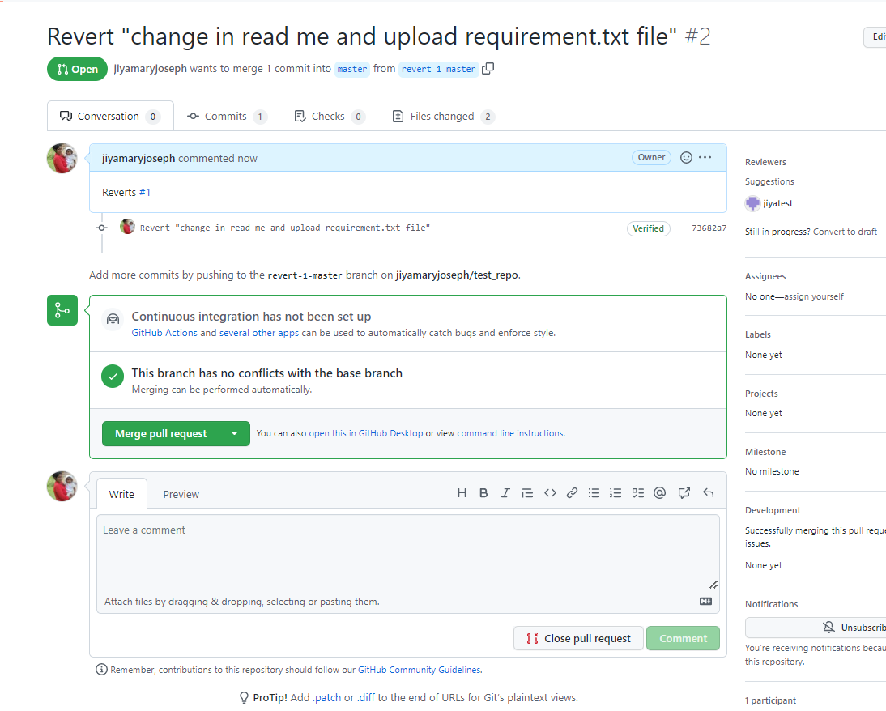

And confirm merge accordingly.

1. 5. Add a Dependabot alerts in your github.(for above cases)

